Meteorite Cleaning
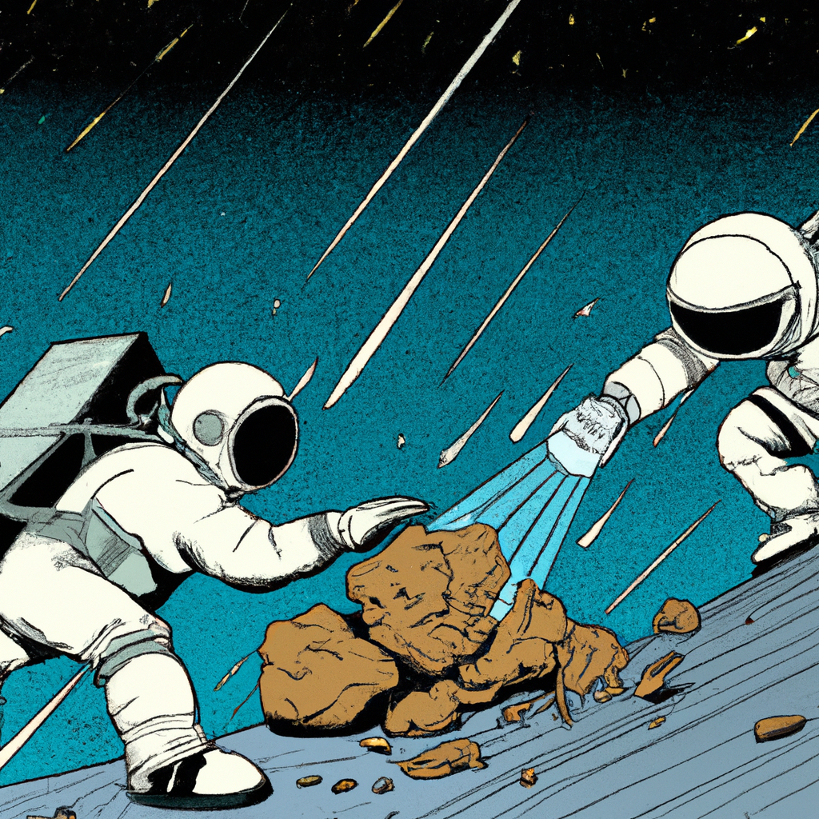“NASA astronauts cleaning a big meteorite, in the style of a science-fiction comic”, generated by DALL·E 2

Problem to Solve
As a data engineer at NASA, you often spend your time cleaning meteorites—or at least the data they create.
You’ve been given a CSV file of historical meteorite landings here on Earth, of which there are quite a few! Your job is to import the data into a SQLite database, cleaning it up along the way. After you’re done, the database will be used in analyses by some of your fellow engineers.

Distribution Code
For this problem, you’ll need to download meteorites.csv, along with an import.sql file in which you’ll write SQL statements to clean the CSV.
Download the distribution code

Specification
In import.sql, write a series of SQL (and SQLite) statements to import and clean the data from meteorites.csv into a table, meteorites, in a database called meteorites.db.
Within meteorites.db, the meteorites table should have the following columns:
Columns in the meteorites table
- id, which represents the unique ID of the meteorite.
- name, which represents the given name of the meteorite.
- class, which is the classification of the meteorite, according to the traditional classification scheme.
- mass, which is the weight of the meteorite, in grams.
- discovery, which is either “Fell” or “Found”. “Fell” indicates the meteorite was seen falling to Earth, whereas “Found” indicates the meteorite was found only after landing on Earth.
- year, which is the year in which the the meteorite was discovered.
- lat, which is the latitude at which the meteorite landed.
- long, which is the longitude at which the meteorite landed.
Keep in mind that not all columns in the CSV should end up in the final table!
To consider the data in the meteorites table clean, you should ensure…
- Any empty values in meteorites.csv are represented by NULL in the meteorites table.
  - Keep in mind that the mass, year, lat, and long columns have empty values in the CSV.
- All columns with decimal values (e.g., 70.4777) should be rounded to the nearest hundredths place (e.g., 70.4777 becomes 70.48).
  - Keep in mind that the mass, lat, and long columns have decimal values.
- All meteorites with the nametype “Relict” are not included in the meteorites table.
- The meteorites are sorted by year, oldest to newest, and then—if any two meteorites landed in the same year—by name, in alphabetical order.
- You’ve updated the IDs of the meteorites from meteorites.csv, according to the order specified in #4.
  - The id of the meteorites should start at 1, beginning with the meteorite that landed in the oldest year and is the first in alphabetical order for that year.

Advice
It can feel overwhelming to know where to start when cleaning such a big data file! Let’s break the problem down into smaller pieces.
Begin by importing meteorites.csv into a temporary table
Start by getting all of the data from meteorites.csv into a temporary table, one called meteorites_temp. A temporary table is a helpful placeholder: you can use it to clean your data until it’s in a form that’s suitable for your final meteorites table.
Before you import a CSV into a SQLite database, it’s best to define the schema for the table into which that data will be imported. In import.sql, then, try the following:
CREATE TABLE "meteorites_temp" (
-- TODO
);
We’ll leave the column names up to you.
Next, recall that .import is a SQLite statement that can import a CSV into a table of your choice. After your CREATE TABLE statement, write a .import statement to import the data from meteorites.csv into the meteorites_temp table.
Finally, per the Usage section below, try creating meteorites.db by running the statements in import.sql.
Write SQL statements to clean the imported data
With your data in a temporary table, continue writing SQL statements to clean the data. Consider how you might update the values of the mass column for instance:
UPDATE "meteorites_temp"
SET "mass" = ...
WHERE ...
You might need to write a few such statements, one (or more) for each column you’re trying to clean.
Transfer the data from your temporary table into a meteorites table
Recall that you can INSERT values into a new table by SELECTing rows from another:
INSERT INTO "table0" ("column0", "column1")
SELECT "column0", "column1" FROM "table1";
When you do so, you can re-order your data using ORDER BY. And, so long as you’ve specified a primary key column in your new table, such a statement will auto-assign new IDs to the inserted rows if none is specified.
Once you’re done with the temporary table, it’s good practice to drop it!

Usage
Let’s introduce a few terminal commands that might come in handy while you’re working on cleaning this data set! Consider the following:
cat import.sql | sqlite3 meteorites.db
The above command can be broken down into two parts:
- cat import.sql outputs the data in import.sql. Try it by itself if you’re curious.
- sqlite3 meteorites.db opens a file called meteorites.db with the sqlite3 engine, as you’re already familiar with.
When these commands are combined with a pipe, |, the data from import.sql is treated as a set of statements for sqlite3 to run on meteorites.db. If meteorites.db doesn’t yet exist, it will be created and the statements in import.sql will be run on it.
What if your import.sql isn’t perfect and you want to re-create the database? Consider deleting the current version of meteorites.db with:
rm meteorites.db
rm stands for remove. If prompted, type “y” followed by enter to confirm the deletion of meteorites.db. From there, you can re-run cat import.sql | sqlite3 meteorites.db to create meteorites.db from scratch.
Looking to speed things up? You can use the up arrow to access previously typed commands in your terminal.

